**1. Write a program to accept n integers from the user into an array. Display the count of odd and even numbers.**

**Code:**

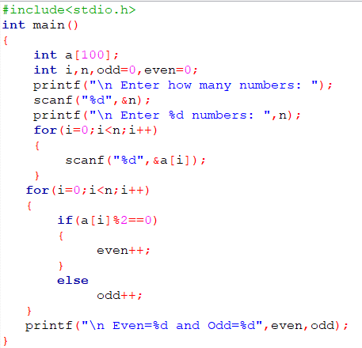

**Output:**

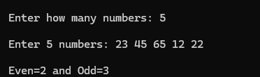

**2. Write a program to accept n doubles into an array. Find the largest element in this array.**

**Code:**

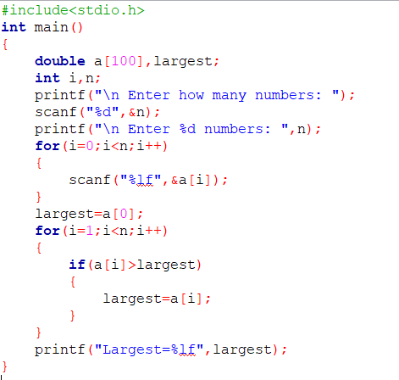

**Output:**

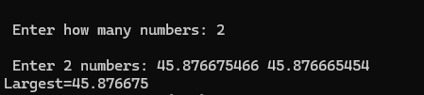

**3. Write a program to initialize an array at compile time with the IT1 Maths marks of n students. Calculate and display the average.**

**Code:**

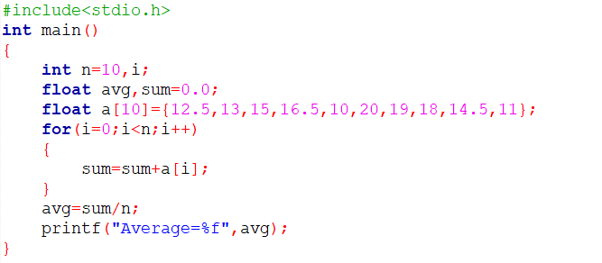

**Output:**



**4. Write a program to accept ‘n’ numbers into and array in main and pass an array to a function ‘cube’. This function will replace each array element with its cube.**

**Code:**

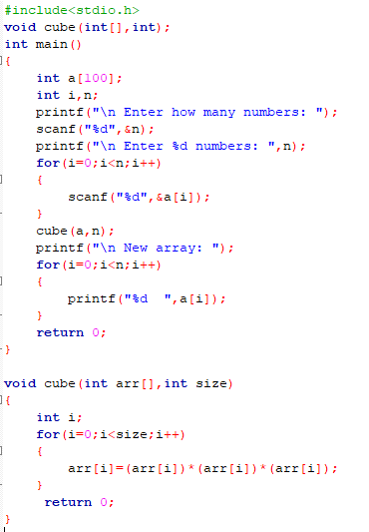

**Output:**

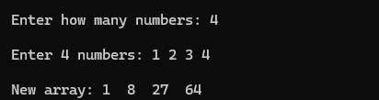

**5. Write a program to demonstrate the use of array of pointers.**

**Code:**

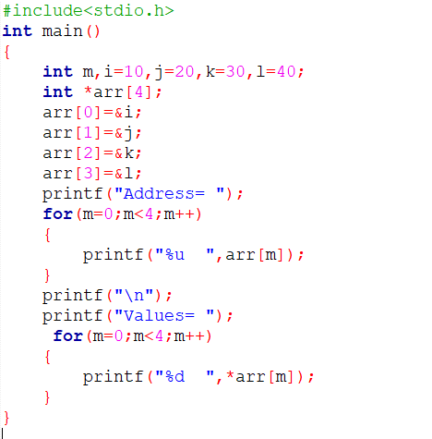

**Output:**

